Open issues on assumptions and results of Ray-Tracing simulations

1. **Positioning of IMT stations at 1.5m and above**

During the previous online discussion, it was recognized that different assumptions on IMT station positioning close to buildings or in the street may explain the differences of the results from Huawei and from France e.g. 35dB median loss for Hong-Kong at 10° elevation angle 1.5m height for Huawei and 16.5dB median loss for France under similar assumptions.

That’s why it was proposed to change the strategy of location of survey points for 5m, 10m (and higher) height simply because it deals with IMT base stations that are deployed in front/facade of buildings (i.e. close to buildings) and not everywhere in the street.

If the IMT station to be positioned is an user equipment at 1.5m height, the situation is pretty different as terminal user may be located everywhere in the street. That’s why it is proposed to align of the following assumptions to run the next simulations:

-          for IMT Base stations (5m and higher height above the ground): survey locations should be close to the buildings

-          for IMT UE (terminal 1.5m): survey locations should be everywhere in the street

1. **Consideration of the vegetation in the clutter**

Although ITU-R Report P.2402 states in its introductory part the following *In general propagation modelling, clutter loss means losses due to objects which are on the ground but which are not the ground itself. In this context "clutter" most often means buildings or vegetation*, it provides this definition in the « ***generation*** propagation modelling » framework and only in the introduction section.

Moreover, ITU-R Report P.2402 states after this sentence the following one : *only covers losses due to urban or suburban clutter so, within this classification, "any man-made objects can be included, particularly those of sizes comparable to buildings, such as bridges"* but not vegetation.

In addition, no other place within this report assumes in the description of the physical mechanisms involved in the loss due to clutter (reflections, diffractions) that vegetation is considered, in particular in sections 2 and 3 describing the *urban clutter* and *the general form of a statistical urban clutter-loss model*.

Conversely, ITU-R Rec P.2108-0 refers to vegetation :

* *Statistical models are to be used when precise knowledge of the radio path is not known such as the width of streets, heights of buildings, depth of vegetation.*
* by recognizing that *Recommendation ITU-R P.833 presents several models to enable the user to evaluate the effect of vegetation on radiowave signals between 30 MHz and 60 GHz*.

That raises the question on whether vegetation should be accounted in the modelling and if it should be, how the effect of the vegetation should be simulated in Ray-Tracing.

Comparison analysis with results from Huawei on two cities (Melbourne and London) for several angles shows that median values of cdf curves of clutter loss are pretty aligned although vegetation was accounted for Huawei and not accounted for our studies (few dBs gap). **Should this trend be confirmed by further investigation** e.g. by considering all elevation angles at a given IMT station height for both cities (all elevation angles were investigated for London but only one for Melbourne), the vegetation would have **a few impact in the R-T simulations**.

1. **Selection of the survey points in the R-T simulations**

As it was outlined in the sensitivity analysis performed on two cities (Melbourne and London), the regularity of the geometrical structure of the city influences the required number of survey points to enable a reliable clutter statistic to be built. Moreover, these survey points should be selected in a random manner in order to avoid favoring any particular structure/geometry from a district of the simulation area in the clutter loss statistics.

That’s it’s recommended to use a sufficient number of survey points when computing the clutter loss cdf to get stable shape and value of its depicting curve e.g. 1000 samples.

1. **Importance of the R-T simulations results over measurements campains**

It is understood that measurements are necessary to be compared with simulation results. It should also kept in mind that it is important to have a sufficiently high number of samples to compute a reliable distribution of the clutter loss because a few points may not capture the varying situation of the loss due to clutter in urban area. That's why if RT is aligned with measurements on several locations, RT could be extended to more sampled locations to get a reliable statistic of clutter loss as it is the purpose of the work in this Correspondence Group.

1. **Clutter database**

Performing Ray-Tracing simulations requires to use a recent clutter database with good accuracy. Thus, the precision of RT simulation depends on digital map accuracy as well as the date of the map. Regarding accuracy, sensitivity analyzis carried out for London and Melbourne assumes 5m resolution for the map while Huawei analysis assumes 1m which suggests that the map grid database is more accurate for the Huawei studies.

Regarding the date of the database, it should be observed that there are differences in locations/absence of buildings when comparing these two databases. Googlemap has been used in order to draw a fair comparison between several locations of the two digital map

1. Melbourne :

Considering Huawei database extracted from doc CG-3K-3M-12_2020_21, the following location highlighed by the black arrow line suggests that this location is an open area in this map.

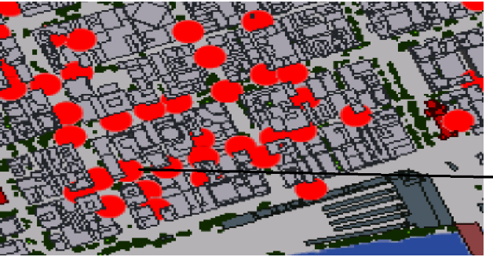

In the database used by ANFR, there is no open area in this location.

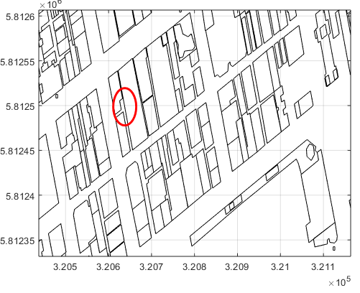

Looking at google map, the location seems to host a building.

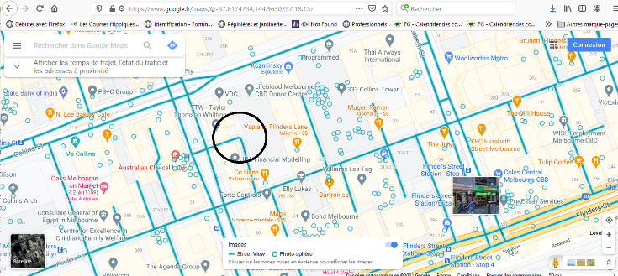

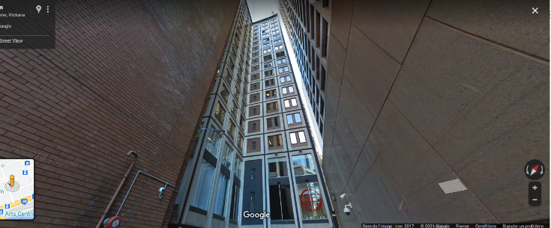

1. London

Similar issue but on the reverse side : the document from Huawei shows a building in the zone pointed by the black arrow line in the map:

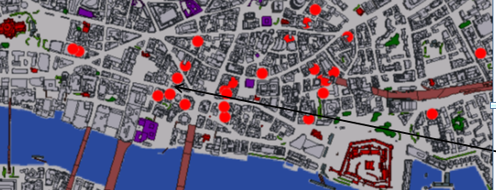

In the document where the comparison analysis with Huawei results are addressed, there is no building at this location.

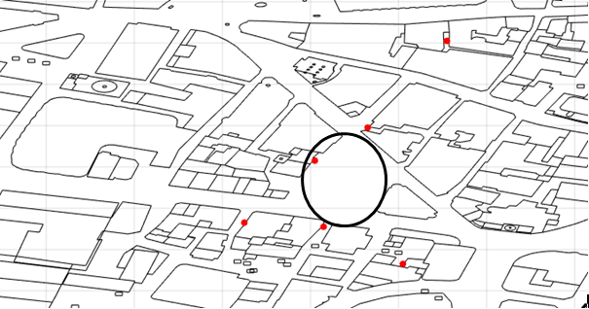

Picture from Googlemap at this location shows that an on-going construction site to be finalized at 2022.

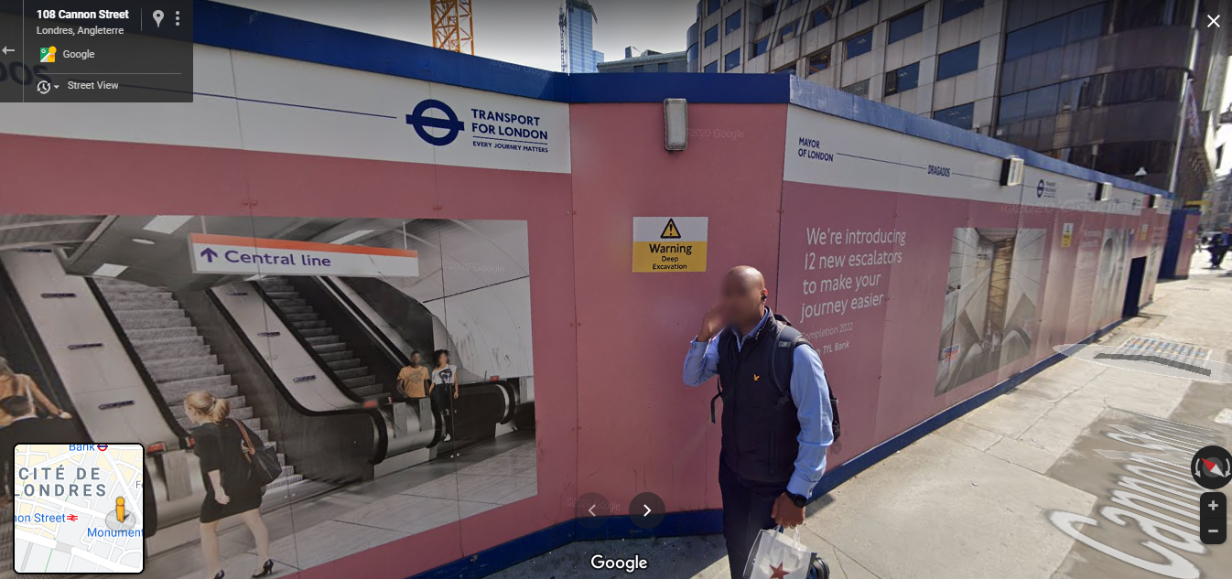

Another example (for the same city) exhibits open area for Huawei document (see below)

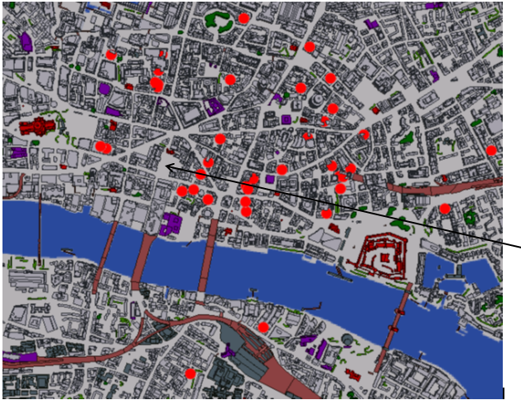

While the French document assumes a building at the same location (see below).

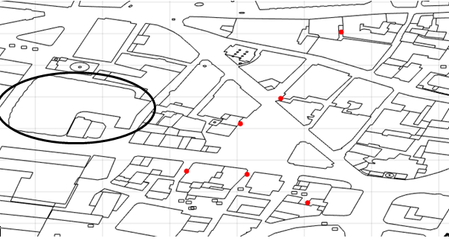

Looking at Googlemap, it appears that there is building at this location.

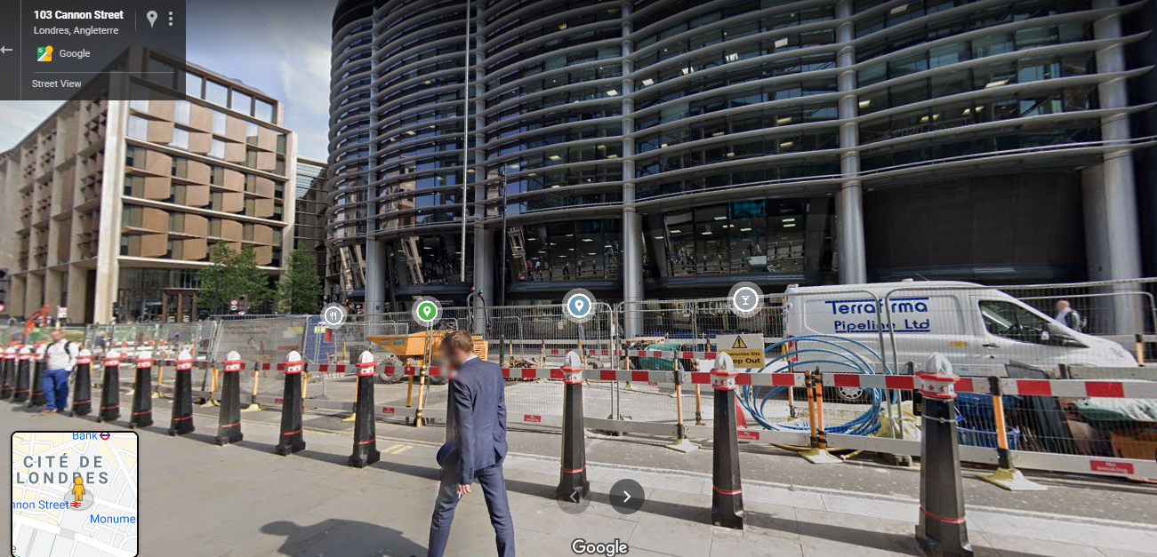

Based on these observations, one could recognize the database used by Huawei for London and Melbourne appears to be older than those used in the document performing R-T simulations in the same environment as Huawei did for two areas in London and Melbourne.

It’s not sure whether a more accurate but older database is more efficient than a less accurate but more recent database. Moreover, comparison analysis between our results and results from Huawei on London city (hRx=5m all elevation angles) and Melbourne (hRx=5m 10°) reveals that they are pretty aligned. This could be confirmed in further analysis with other scenarios if needed.

This trend tends to suggest that the accuracy and date of database **could not prevent R-T simulation results to be similar when taking the same survey points**.

1. **Max number of reflections and diffractions accounted in the R-T simulations**

As explained in the French document presented during the previous online discussions session, the assessment of the max number of reflections and diffractions over multiple paths allows to achieve stability in the shape of the clutter loss cdf curve. For higher elevation angle, it could be agreeable to assume a max number of 2 reflections and 1/2 diffractions. For the lower elevation angle, e.g.10 degree, results presented during the previous meeting showed that 2 reflections and 1 diffraction is not sufficient, that’s why 4 max number of reflections was taken. That’s why any **other RT simulations drawing such comparison** are welcome to confirm this trend (or not).

1. **Probability of no reflection over the building but only building penetration ?**

As indicated in the French document discussed last only discussion session, The transmission rays inside a building at 7GHz are ignored i.e. no building entry loss was considered in the analysis. If such transmission effect exists, it will add received signal at the outdoor receiving point and so decrease the clutter loss for the outdoor points. In case the signal goes through the building without reflection, there will a highly attenuated signal at this frequency range. In such a situation, the diffracted signal around the roof of the building will be probably much higher than the transmitted signal through the building and it is taken into account by Ray-Tracing simulations performed for Rennes, Hong-Kong, Melbourne and London.